***Version: 2016-10-02***

**Suggestions on installing Cygwin, and running command lines to download data:**

1. **Installing Cygwin**.

Further to downloading the compatible bit-version of Cygwin in your computer (32/64 bit), one of the reasons why the command line may not generate csv files with data is because there may a little installation missteps when setting up Cygwin. The following are some directions that you may follow in order to set the program properly and solve issues:

* When prompt to the window “Available Download Sites” select the option “cygwin.mirrors.hoobly.com”

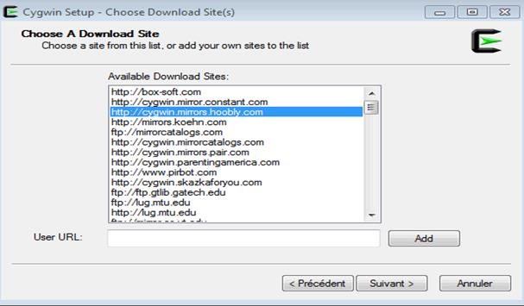

* **Then, at the step “Select Packages” during the installation process, Search for wget, click on the web@default option and click on skip, and click next.**

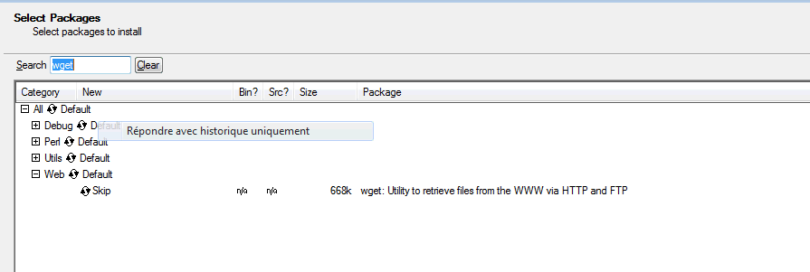

1. **Using the full command line to extract data.** The command line in our “Readme.txt” document was designed to be used as a whole, for Cygwin to successfully download any hourly, daily, or monthly data if available for a particular Climate station at once. Therefore, if you try to breakdown and only use just parts of the command line, it may not work or prompt you to any valid site. Also, if you happen to skip some of the code provided, Cygwin will not be able to extract data using the script as the connection to the server is broken.
2. **Using the proper stationID associated to the Climate Station of your interest.** One of the most common errors when using the command line is to confuse the stationID values needed from a Climate station.

* The file “Station Inventory EN.csv” included on the Get More Data FTP site will serve as reference to find the corresponding “stationID(s)” for the Climate station(s) of your interest.

1. **Copying the command line from program to program.** As small as it looks, sometimes operating systems change symbols contained in the original command line when copied from one program to another. Please see the example below:

* **The correct quotations to use (highlighted in blue) are the ones included in the original command line of our Readme text file:**

for year in `seq 1998 2008`;do for month in `seq 1 12`;do wget --content-disposition "[http://climate.weather.gc.ca/climate_data/bulk_data_e.html?format=csv&stationID=1706&Year=${year}&Month=${month}&Day=14&timeframe=1&submit= Download+Data](http://climate.weather.gc.ca/climate_data/bulk_data_e.html?format=csv&stationID=1706&Year=$%7byear%7d&Month=$%7bmonth%7d&Day=14&timeframe=1&submit=%20Download+Data)" ;done;done

* **After copying the command line into another program (for example Word) and then into Cygwin, the format of the quotations change as shown (highlighted in green) below:**

for year in 'seq 1998 2008';do for month in 'seq 1 12';do wget --content-disposition "[http://climate.weather.gc.ca/climate_data/bulk_data_e.html?format=csv&stationID=1706&Year=${year}&Month=${month}&Day=14&timeframe=1&submit= Download+Data](http://climate.weather.gc.ca/climate_data/bulk_data_e.html?format=csv&stationID=1706&Year=$%7byear%7d&Month=$%7bmonth%7d&Day=14&timeframe=1&submit=%20Download+Data)" ;done;done

In many cases, copying commands of this kind from program to program can carry some hidden coding that may change the format of the original symbols and automatically disable the scripts to use.

It is highly recommended to copy the original command line (provided in the Readme text file) directly into the program Notepad to avoid any changes from the very beginning. Once copied into Notepad, make the proper changes for **years, stationID** and **timeframe (1=hourly, 2=daily – 3=-monthly)** that correspond to the specific Climate station that you want to download data from, and then copy the modified command directly into Cygwin. The program should extract running and extracting the data

Once the script is done running the query, the “.csv” output files will be found in the “home” folder of the “cygwin64” (or cygwin32 if applicable) directory under the Local disk “C”. The screen capture below will show you the path to follow on the “My Computer” application:

